Enter here your title

A. Author1^{1, 2}, A. Author2¹, A. Author3^{1, 2},

(1) Affiliation author 1
(2) Affiliation author 2

Abstract:
Please use less than 400 words in the abstract and keep it to one page.
Font used is Liberation Serif size 12.

The biennial PHYSMOD workshop provides since 2001 a unique forum for experts, young scientists and students where the most recent advances in fluid modelling, the state-of-the-art in experimental work and new emerging research areas are discussed and assessed in an open-minded and friendly atmosphere. One of the main purposes is to provide a wide platform for information exchange and knowledge transfer between participants active in the physical (e.g in wind tunnels and water flumes) modelling of atmospheric flow and dispersion.

Key topics of theworkshop: flow and dispersion in the atmospheric boundary layer in urban areas, effect of roughness on transport and diffusion, boundary layer modelling for wind technology and wind energy research, test data and validation of numerical and analytical modelling tools, quality assurance and improvement of boundary layer modelling techniques, OoPs session (Obnoxious Operational ProblemS) special session devoted to experimental or operational problems and their solutions.
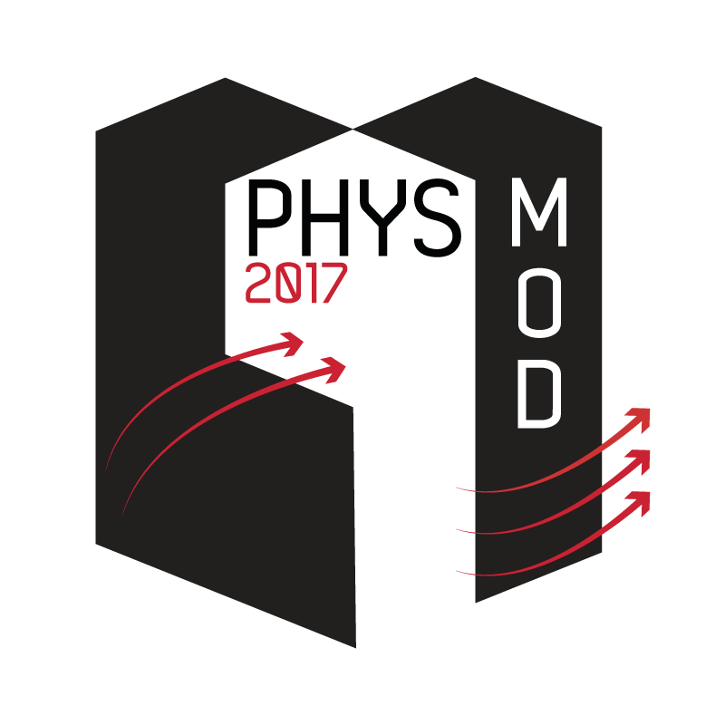
Fig. 1: Caption of the figure

References:
[1]
[2]
[3]

